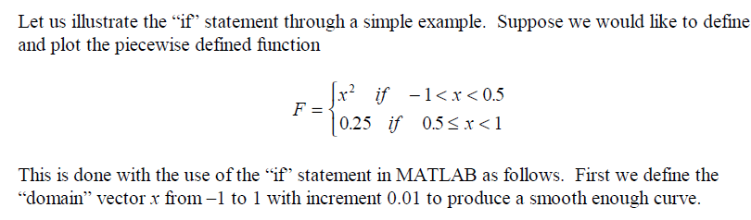

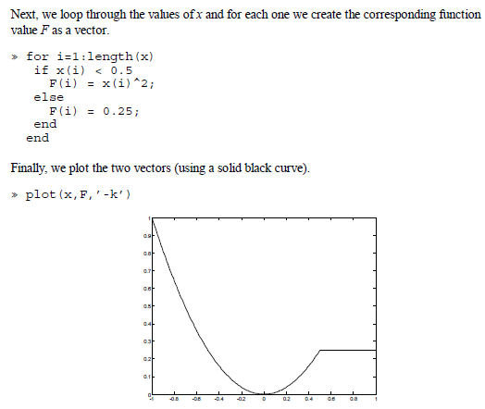

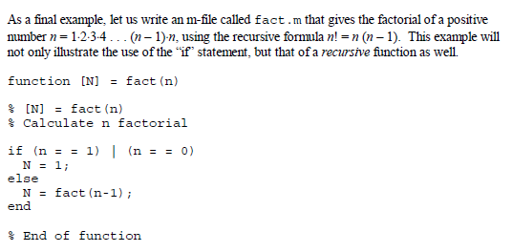

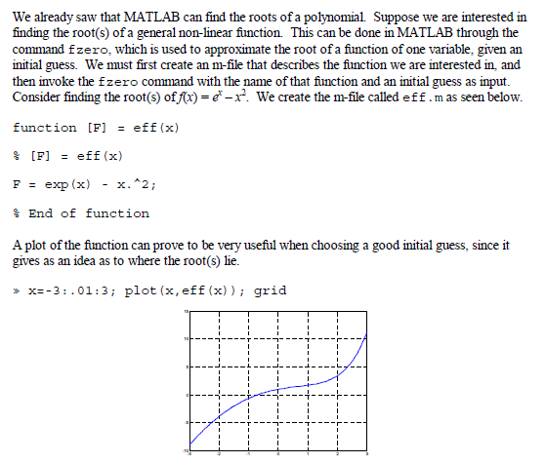

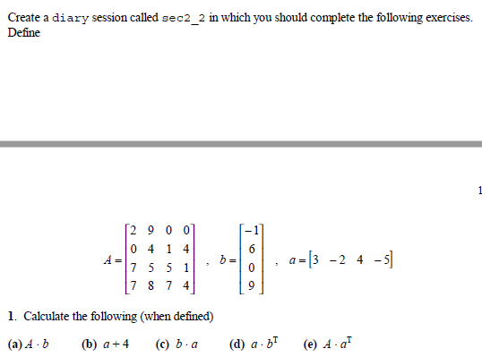

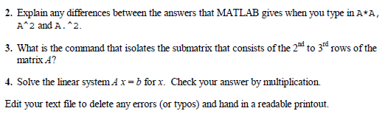

he author can accept an input x value from 0 to 100 while calculating and displaying the letter level corresponding to the one listed in the following list.

A x ≥ 90

B 80 ≤ x ≤ 89

C 70 ≤ x ≤79

D 60 ≤ x ≤ 69

E x < 60

a. Use nested if statements in your program (you cannot use elseif).

b. Use only the elseif clause in your program.